**User Story 1: Import .csv or .txt file**

**As** a Field Engineer, **I want to** load valid well trajectory data points (less than 100001), stored in txt file or csv file, into the program, **so that** I can visualize the target well trajectory.

**Priority:** 1

**Dependency:**

**Effort Estimation(day):** 0.5

**User Story Description:** A valid well trajectory data point should contain and only contain x,y,z coordinate. No missing coordinates or extra coordinates are allowed. The coordinates should be numerical and arranged in the order of x, y, z. The x,y,z coordinates should be separated by commas (for example: 1,1,0).

**Acceptance Criteria:**

AC1 (happy path):

**Given** the program is run successfully and Well Trajectory Visualization form is ready.

**When** I click the Open File button at the Toobar or the Open File button at File under Main Menu.

**Then** a open file dialogue is opened, which only display .csv or .txt file.

AC2 (happy path):

**Given** the open file dialogue only for .csv or .txt file is opened.

And less than 30 well trajectories have been loaded into the system.

**When** I select an accessible .csv or .txt file contains less than 100001 valid well trajectory data points.

**Then** a message box is popped up with text "New Well loading from {file path} succeed." within 60 seconds.

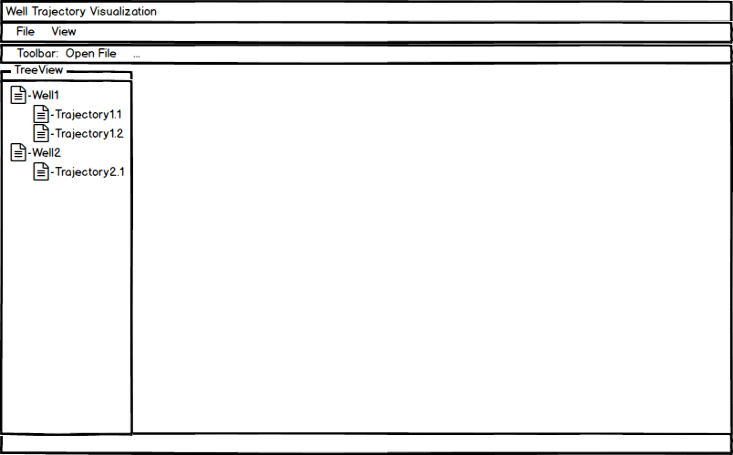And the file name of the selected file is listed in the Treeview (Fig.1).

Fig.1

AC3 (negative path):

**Given** the open file dialogue only for .csv or .txt file is opened.

**When** I select a inaccessible .csv or .txt file.

**Then** a message box is popped up with error message”Loading {file path} failed. Error: File not accessible.”

AC4 (negative path):

**Given** the open file dialogue only for .csv or .txt file is opened.

And less than 30 well trajectories have been loaded into the system.

**When** I select a .csv or .txt file that has extra coordinate or coordinates.

**Then** a message box is popped up with error message ”Loading {file path} failed. Error in Line {line number}: Data overflow.”

AC5 (negative path):

**Given** the open file dialogue only for .csv or .txt file is opened.

And less than 30 well trajectories have been loaded into the system.

**When** I select a .csv or .txt file that has missing coordinate or coordinates.

**Then** a message box is popped up with error message ”Loading {file path} failed. Error in Line {line number}: Data lost.”

AC6 (negative path):

**Given** the open file dialogue only for .csv or .txt file is opened.

And less than 30 well trajectories have been loaded into the system.

**When** I select a .csv or .txt file that has non numerical data and contains less than 100001 valid well trajectory data points.

Then a message box is popped up with error message ”Loading {file path} failed. Error in Line {lineNumber}: Non-float numbers in data.”

AC8 (negative path):

**Given** the open file dialogue only for .csv or .txt file is opened.

And less than 30 well trajectories have been loaded into the system.

**When** I select a .csv or .txt file that has already been loaded into the system.

**Then** a message box is popped up with error message.

AC9 (negative path):

**Given** the open file dialogue only for .csv or .txt file is opened.

And less than 30 well trajectories have been loaded into the system.

**When** I select a .csv or .txt file that has already been loaded into the system.

**Then** a message box is popped up with error message.

AC10 (negative path):

**Given** the open file dialogue only for .csv or .txt file is opened.

And less than 30 well trajectories have been loaded into the system.

**When** I select a .txt file in which the coordinates are not separated by commas contains more than 100000 valid data points.

**Then** a message box is popped up with error message”Loading {file path} failed. Error in Line {line number}: Data overflow..”

AC11 (negative path):

**Given** the open file dialogue only for .csv or .txt file is opened.

And 30 well trajectories have been loaded into the system.

**When** I select an accessible .csv or .txt file.

**Then** a message box is popped up with error message”Loading {filePath} failed. Reach the well trajectory loading limit.”

**User Story 2: Visualize well trajectory**

**As** a Field Engineer, **I want** to see the main view, top view and left view of the well trajectory displayed in one page, **so that** I can have a rough understanding of the well trajectory profile in different projection plane and imagine the well trajectory in 3D.

**Priority:** 2

**Dependency:** Import .csv or .txt file

**Effort Estimation(day):** 1

**Acceptance Criteria:**

AC1 (happy path):

**Given** at least one well trajectory has been imported into the system.

And less than 10 tab pages have been opened.

**When** I double click the target well trajectory in the Treeview.

**Then** the main view, top view and left view of the well trajectory are displayed at one tab page (Fig.2).

And the tab page is labeled with the file name of the well trajectory (Fig.2).

And the tab page is focused (Fig.2).

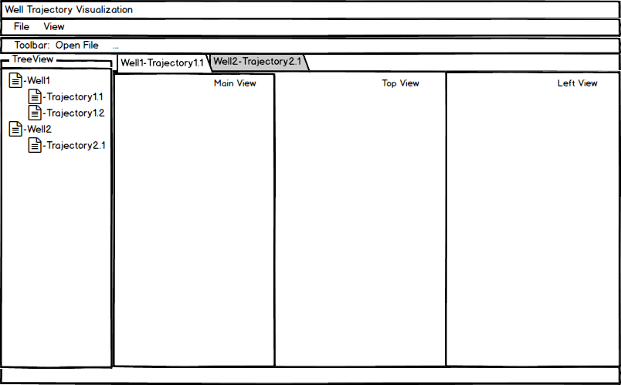

Fig.2

AC2 (happy path):

**Given** at least one well trajectory has been imported into the system.

And at least 1 tab page has been opened.

**When** I click the close button of one tab page.

**Then** that tab page should be closed.

AC3 (happy path):

**Given** at least one well trajectory has been imported into the system.

And at least 1 tab page has been opened.

**When** I click one tab page.

**Then** that tab page is focused.

And the main view, top view and left view of that well trajectory are displayed at the tab page (Fig.2).

AC4 (negative path):

**Given** at least 11 well trajectories have been imported into the system.

And 10 tab pages have been opened.

**When** I double click a unopened well trajectory in the Treeview.

**Then** a message box is popped up with error message “Only 10 pages can be opened. Please close a page before opening a new one.”

**User Story 3: Highlighted well trajectory data points**

**As** a Field Engineer, **I want to** see the well trajectory data points highlighted on the well trajectory, **so that** I can know the position of the well trajectory data points.

**Priority:** 3

**Dependency:** Import .csv or .txt file, Visualize well trajectory

**Effort Estimation(day):** 0.5

**Acceptance Criteria:**

AC1 (happy path):

**Given** at least one well trajectory has been imported into the system.

And less than 10 tab pages have been opened.

**When** I double click the target well trajectory in the Treeview.

**Then** the main view, top view and left view of the well trajectory are displayed at one tab page.

And the tab page is labeled with the file name of the well trajectory.

And the tab page is focused.

And the well trajectory data points are highlighted using asterisk.

**User Story 4: Default Page**

**As** a Field Engineer, **I want to** see the shortcuts information of the major action at default page, **so that** I can easily know the shortcuts of the major action.

**Priority:** 5

**Dependency:**

**Effort Estimation(day):** 0.5

**Acceptance Criteria:**

AC1 (happy path):

**Given** the program can be run successfully.

**When** I run the program.

**Then** the default page includes the shortcuts information of Load Well Trajectory, Save View, Open Customized View Editor, View Source File should be displayed.

AC2 (happy path):

**Given** at least one well trajectory has been imported into the system.

And no tab pages are opened.

And default page is opened.

**When** I double click the target well trajectory in the Treeview.

**Then** the default page should be invisible.

And the tab page should be opened.

AC3 (happy path):

**Given** at least one well trajectory has been imported into the system.

One tab page is opened.

**When** I close the tab page.

**Then** the default page includes the shortcuts information of Load Well Trajectory, Save View, Open Customized View Editor, View Source File should be displayed.